COMMONLY USED PORTS

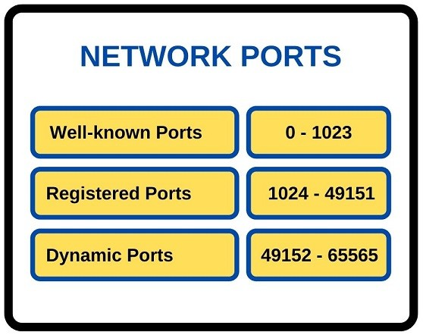

Class: Cyber Security

Prepared by: Rickardo Brown, St Patrick Currey

Date: 1/05/2023

Introduction:

In computer networking, ports are virtual endpoints for communication between computers. Each port is assigned a number and a protocol to determine its function. In this report, we will discuss the most commonly used ports in networking, their functions, and why it is important to know them.

Commonly Used Ports and Their Functions:

The following is a list of the most commonly used ports in networking, along with their respective protocols and functions:

1. Port 21: File Transfer Protocol (FTP) - used for transferring files between computers. It is commonly used for uploading and downloading files to and from a web server.
2. Port 22: Secure Shell (SSH) - used for secure remote login and other secure network services over an insecure network. It is used to establish a secure connection between the client and the server.
3. Port 25: Simple Mail Transfer Protocol (SMTP) - used for sending and receiving email messages. It is used to establish a connection between the email client and the email server.
4. Port 53: Domain Name System (DNS) - used for resolving domain names to IP addresses. It is used to establish a connection between the client and the DNS server.
5. Port 80: Hypertext Transfer Protocol (HTTP) - used for accessing web pages on the World Wide Web. It is used to establish a connection between the client and the web server.
6. Port 110: Post Office Protocol version 3 (POP3) - used for retrieving email messages from an email server. It is used to establish a connection between the email client and the email server.
7. Port 143: Internet Message Access Protocol (IMAP) - used for retrieving email messages from an email server. It is used to establish a connection between the email client and the email server.
8. Port 3389: Remote Desktop Protocol (RDP) - used for remote access to a computer or a server. It is used to establish a connection between the client and the remote desktop server.
9. Port 1194: OpenVPN - used for secure and private virtual private network (VPN) connections. It is used to establish a connection between the client and the OpenVPN server.
10. Port 443: Hypertext Transfer Protocol Secure (HTTPS) - used for secure web browsing. It is used to establish a secure connection between the client and the web server.

Importance of Knowing These Ports and Their Functions:

It is important to know these ports and their functions for several reasons. Firstly, it allows network administrators to identify which applications are using which ports and to ensure that they are working correctly. Secondly, it helps in troubleshooting network issues by allowing administrators to identify the source of the problem. Lastly, it helps in network security by allowing administrators to identify and block unauthorized network traffic.

Examples of Situations Where Knowledge of These Ports and Their Functions Would Be Useful:

* When troubleshooting network issues, such as slow network performance or connection problems.
* When configuring firewalls or other network security measures.
* When setting up network applications, such as email servers or web servers.
* When implementing remote access to a network or computer.

Conclusion:

Knowing the most commonly used ports in networking and their functions is essential for network administrators to effectively manage and secure their networks. By understanding these ports, administrators can troubleshoot network issues, ensure the correct functioning of applications, and protect their networks from unauthorized access.

| **Port Number** | **Protocol** | **Function** |
| --- | --- | --- |
| 21 | FTP | File Transfer Protocol |
| 22 | SSH | Secure Shell |
| 25 | SMTP | Simple Mail Transfer Protocol |
| 53 | DNS | Domain Name System |
| 80 | HTTP | Hypertext Transfer Protocol |
| 110 | POP3 | Post Office Protocol version 3 |
| 143 | IMAP | Internet Message Access Protocol |
| 3389 | RDP | Remote Desktop Protocol |
| 1194 | OpenVPN | OpenVPN Service |
| 443 | HTTPS | Hypertext Transfer Protocol Secure |